- List all the main components you find inside a desktop PC after opening the cabinet, and write a short description (1-2 lines) for each.

- Motherboard:
- The main circuit board that connects all internal components, allowing them to communicate with each other.
- CPU:
- The "brain" of the computer that processes instructions and performs calculations for every task.
- RAM:
- Short-term volatile memory that temporarily holds data for programs currently in active use.
- SSD:
- Permanent or long-term drives that store your operating system, apps, and personal files.
- SMPS:
- Converts household alternating current (AC) power into direct current (DC) power usable by internal parts.
- CPU Cooler / Heat Sink and Fans:
- A combination of metal fins, liquid tubes, and fans that pulls heat away from the processor and other hot parts.
- CMOS Battery:
- A small coin-cell battery on the motherboard that saves BIOS settings and the system clock when the PC is unplugged.

- Take clear photos or draw labelled diagrams of each step as you disassemble a desktop PC, and organize them in a document with captions explaining what you did at each step.<br><br><em><strong>Hint:</strong> Include steps like unplugging power, removing side panel, disconnecting cables, and removing RAM, HDD/SSD, and motherboard.</em>
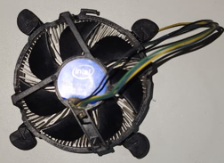
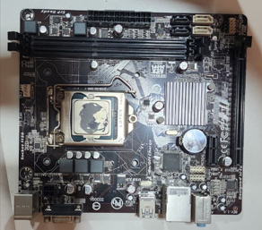
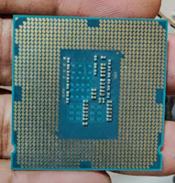
CPU cooler fan
CPU
Motherboard

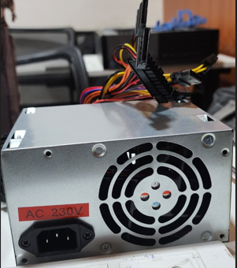
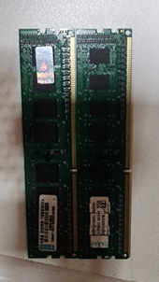
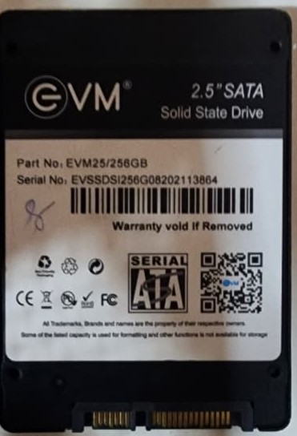

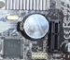
CMOS Battery

SMPS

SSD

RAM

- Reassemble the PC you disassembled, documenting each step with a brief explanation of what you connected or installed and why the order matters.

SMPS
Audio connector

USB connector
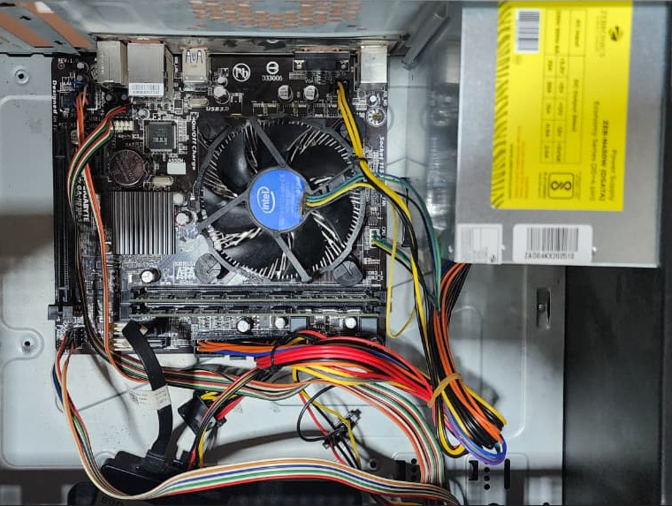
CPU fan connector
SMPS 24 pin connector
SSD SATA Cable
COMS battery
Motherboard
SSD
CPU cooling fan
RAM

- Create a checklist of safety precautions and tools needed before starting the PC assembly/disassembly process, and explain why each is important.

- Small screwdriver:
  - Used to loosen and tighten standard screws on the PC case, motherboard, and component mounts.
- Anti-static wrist strap:
  - Worn around your wrist and clipped to a grounded metal object to drain static electricity.
- Magnetic screw holder or small container:
  - Keeps tiny screws organized so you do not lose them or let them roll onto the motherboard.
- Tweezers or needle-nose pliers:
  - Helps you pick up dropped screws, jumpers, or small connectors in tight spaces.
- Smartphone or notepad:
  - Allows you to take reference photos of cable routings and header locations before unplugging them.
- Zip ties or Velcro straps:
  - Used for neat, safe cable management during reassembly.

